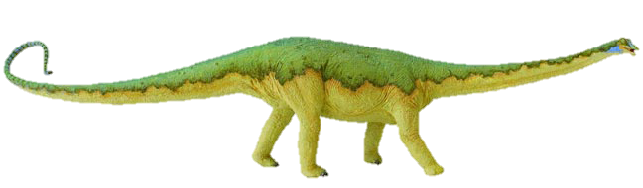
Long and short o sound sort
Sometimes it’s helpful to say that short sounds are short and bouncy, and to make a bouncing ball action as you say them; while long sounds can be stretched, exaggerating the sound slightly, whilst making a stretching elastic kind of movement.
Cut this top row off before you give the sort to pupils!

long vowel |  | 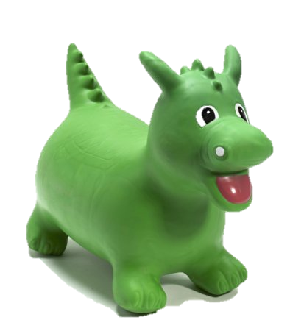  short  vowel
Sort by long or short sound – helps children to look for the single short o grapheme or to see it in combination with other letters to make a digraph with a long sound. | 
cot | bottom | toast
froze | exlode | bone
toe | go | sew
nose | foam | phone
load | ago | oat
not | hot | fox
job | log | rot
cog | pot | pop

